**Aim:**

To change the hardware compatibility of a Virtual Machine (either by cloning or creating a new one) which is already created and configured, using VirtualBox.

**Procedure:**

1. Open VMware Workstation:

* Launch VMware Workstation on the host system.
* Select the Virtual Machine whose hardware compatibility is to be changed.

2. Shut Down the VM:

* Ensure the virtual machine is powered off before making changes.

3. Change Hardware Compatibility:

* Right-click the VM → Select Manage → Change Hardware Compatibility.
* The “Change Hardware Compatibility Wizard” opens.
* Choose the desired compatibility version (e.g., Workstation 15.x, 16.x, etc.).
* Decide whether to keep the existing VM as a backup or create a new copy.
* Click Finish to apply changes.

4. Modify Hardware Resources (if required):

* Right-click the VM → Select Settings.
* Adjust CPU, RAM, hard disk size, network adapter, or display settings.

5. Optional – Clone the VM with New Compatibility:

* Right-click the VM → Select Manage → Clone.
* Provide a new name and location.
* Set the desired hardware compatibility version during clone creation.

6. Start the VM:

* Power on the VM.
* Verify that the operating system boots successfully and runs with the new compatibility settings.

**OUTPUT:**

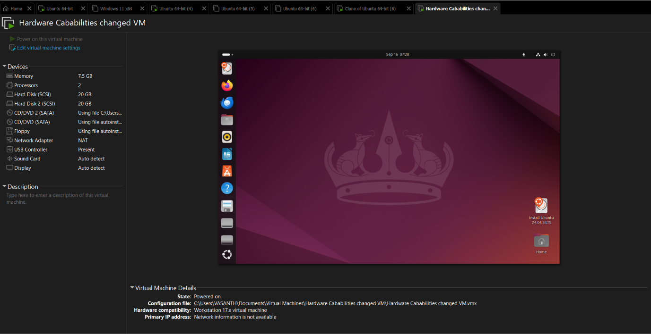

**Result:**

The hardware compatibility of a Virtual Machine was successfully changed in VMware Workstation by using the compatibility wizard and modifying resources (CPU, RAM, storage, etc.). The VM booted and operated properly with the updated configuration.